spring framework with ORM : Hibernate or JPA.

Spring framework using annotation / xml we can use

1. Jdbc
2. Hibernate
3. Jpa

Spring boot with Rest API with JPA

<https://start.spring.io/>

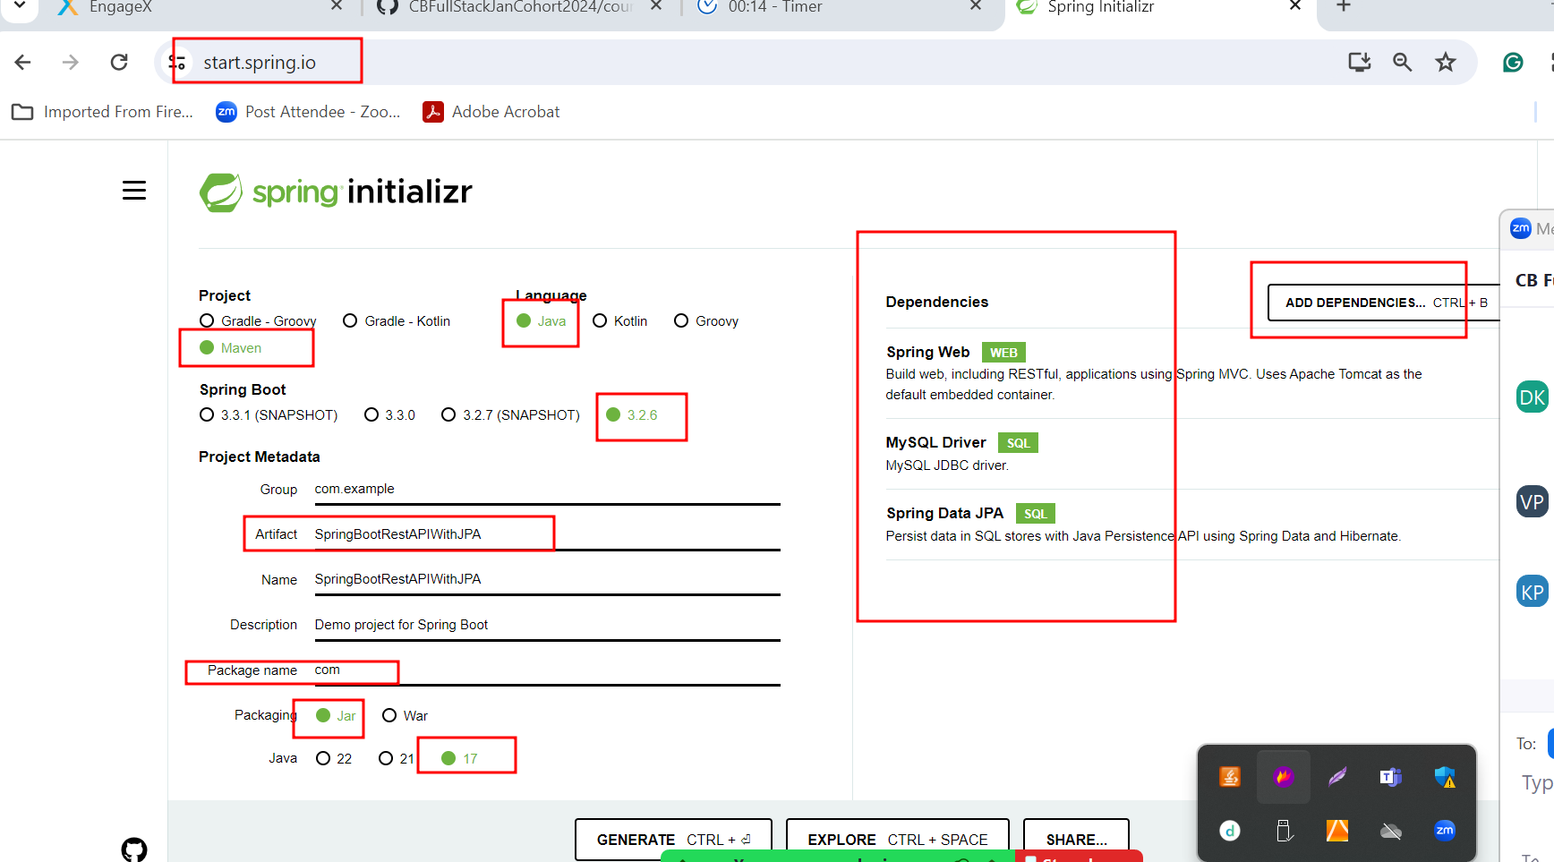

In spring boot

application.properties or application.yml

this file contains all configuration details depending upon project requirement.

Like database information

If we want to write Database Logic using JDBC or Hibernate or JPA we need to use DAO class (Data Access Object) which contains pure business logic.

Dao : pure database login

Service : this class contains business logic.

Model layer -🡪 JavaBean/Entity class, Service class, Dao class, Resource layer etc.

Controller layer : it provide bridge between view an model layer.

@Controller annotation : then view can be JSP or Thymeleaf (dynamic html)

@RestController annotation : it consume and produce the in the form JSON.

If we want to share the data between Spring boot controller and thymeleaf view then we need to use the concept as